
DEPARTMENT OF CSE
PROJECT ABSTRACT SUBMISSION
COURSE: ADAPTIVE Software Engineering PROJECT – 124CI3201
A.Y. 2026 - 2027
TITLE OF THE PROJECT | ADAPTIVE TASK MANAGER
S. No. | University ID | Name
1 | 2420030386 | G. Valli Vidya
2 | 2420030388 | M. Yasasvi
3
Name of the Guide |  | Dr. Archana Kalidindi

System Architecture
The Adaptive Task Management System follows a layered architecture in which the user interacts with a React-based frontend, while the backend manages tasks, authentication, adaptive processing, and communication with the database. User and task information is stored in MongoDB, including task history and behavioral data. The Adaptive Decision Engine analyzes this information to dynamically modify task priorities, schedules, reminders, and recommendations. An AI module provides additional features such as natural-language task creation and task decomposition. The resulting personalized information is then displayed to the user, creating a continuous feedback loop for further adaptation.
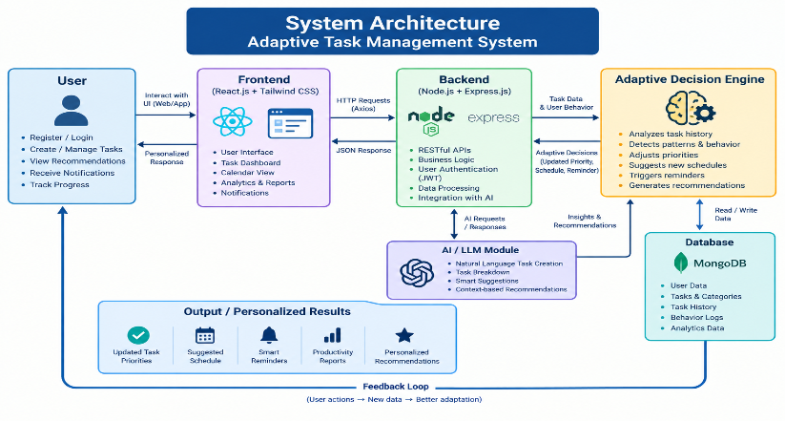
Signature of the Guide HOD
Dr. Archana Kalidindi Venkateswara Rao Pulipati

